CO1 ASSESSMENT TOOL 1 – CASE STUDY ANALYSIS
Case Study 15: Intelligent Disaster Emergency Response Platform
1. Understand the Problem Statement
During floods, earthquakes, cyclones and other disasters, many people need emergency help. Rescue teams, hospitals, shelters and authorities need to share information quickly. Using phone calls, messages and manual records can cause delays and confusion.
The proposed Intelligent Disaster Emergency Response Platform is a software system that manages emergency incidents, affected areas, rescue teams, resources and shelters in one platform.
Objectives
- To register and manage emergency incidents.
- To locate affected areas.
- To manage rescue teams and resources.
- To identify available shelters.
- To prioritize emergency requests.
- To provide real-time status updates.
Scope
The system can be used by disaster management authorities, rescue teams, hospitals, police, volunteers and shelter managers. It helps them coordinate rescue and relief activities through a single platform.
2. Stakeholder and Challenge Analysis
Key Stakeholders
Stakeholder | Responsibility
Disaster Management Authority | Manage overall disaster response
Rescue Teams | Rescue affected people
Affected People | Report emergencies and request help
Police/Fire Services | Provide emergency support
Hospitals | Provide medical treatment
Shelter Managers | Manage shelter availability
Volunteers | Support relief activities
System Administrator | Manage system and users
Major Challenges
- Delay in receiving emergency information.
- Difficulty in managing rescue resources.
- Emergency requests may not be prioritized correctly.
- Lack of updated shelter information.
- Poor coordination between different agencies.
- Difficulty in tracking rescue activities.
- Manual management of large amounts of data.

3. Current System Analysis
Currently, disaster information is commonly collected through phone calls, messages, emails and manual records. Different departments may maintain separate information.
Strengths
- Easy to use existing communication methods.
- Emergency departments already have trained staff.
- Direct communication is possible.
Limitations
- Information is stored in different places.
- Emergency requests can be delayed.
- Resource availability is difficult to track.
- No single real-time view of the disaster.
- Manual report preparation takes time.

Identified Gap
There is a need for a centralized system that connects emergency reports, affected areas, rescue teams, resources and shelters.

4. Proposed Software Solution and Engineering Principles
The proposed system will be a web-based disaster emergency response platform.

Main Modules
- Emergency Management – Register and update incidents.
- Affected Area Management – Record disaster locations and severity.
- Rescue Team Management – Assign and track rescue teams.
- Resource Management – Manage vehicles, medicines, food and equipment.
- Shelter Management – Track shelter location and available capacity.
- Priority Management – Classify requests as High, Medium or Low priority.
- Reports – Generate disaster response reports.

Requirements
Functional Requirements:
- User login
- Emergency registration
- Rescue team assignment
- Resource management
- Shelter management
- Emergency prioritization
- Status updates
- Report generation

Non-Functional Requirements:
- Security
- Reliability
- Scalability
- Usability
- Maintainability
- Fast performance

Software Engineering Principles
- Modularity: System is divided into separate modules.
- Scalability: Can support more users and incidents.
- Maintainability: Modules can be easily updated.
- Reliability: Emergency information is stored and updated correctly.
- Security: Only authorized users can access important data.
- Usability: Simple interface for emergency users.

5. Methodology / Framework Justification
Selected Methodology: Agile Scrum

Agile Scrum is suitable because the requirements of a disaster management system can change based on user feedback.
The project can be developed in small Sprints:
- Sprint 1: Login and Emergency Management
- Sprint 2: Rescue Team and Resource Management
- Sprint 3: Shelter and Priority Management
- Sprint 4: Reports, Testing and Improvements

Agile provides:
- Continuous feedback.
- Faster development.
- Regular testing.
- Easy requirement changes.
- Better teamwork.
- Continuous improvement.
Jira Project Management
Jira can be used to manage the Scrum project. Epics, user stories, tasks and Sprints can be created and tracked using the Jira board.
Jira
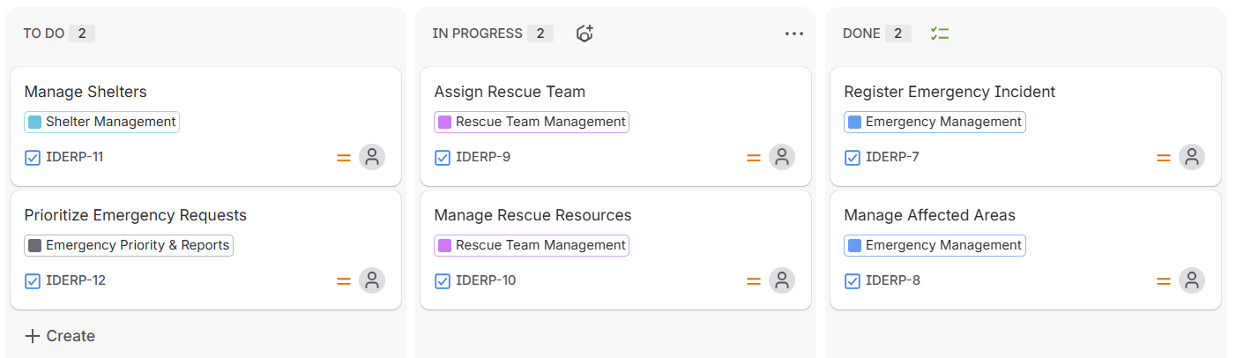
Figure 1: Jira Scrum Board for Intelligent Disaster Emergency Response Platform
6. Expected Outcomes and Limitations
Expected Outcomes
- Faster emergency response.
- Better resource allocation.
- Improved coordination between agencies.
- Real-time disaster information.
- Reduced response delays.
- Better shelter management.
- Proper prioritization of emergency requests.

Limitations
- System depends on internet and communication networks.
- Incorrect data may affect decisions.
- High disaster traffic may affect system performance.
- Users need basic training.
- The system cannot completely replace human decision-making.

Future Enhancements
- Mobile application.
- GPS-based rescue team tracking.
- AI-based emergency prioritization.
- Weather alert integration.
- SMS notifications.
- Multilingual support.
Conclusion
The Intelligent Disaster Emergency Response Platform provides a centralized solution for managing disaster incidents, rescue teams, resources and shelters. By using Agile Scrum and Jira, the system can be developed and improved through continuous feedback. The solution can reduce delays and improve disaster response coordination.

